CSS: Cascading style sheet
- Definition: use for style of doc.
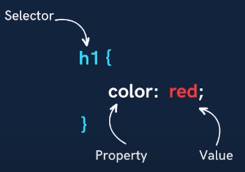
- Syntax:
  - Selector
  - Property
  - Value
- Including CSS
  - Inline (<h1 style="color: blue;">Suraj Arya</h1>)
  - Internal (<head><style>h1 {color: yellow;}</style></head>)
  - External (<link rel="stylesheet" href="styles.css">)
- Color Property
  - Foreground (color: blue;)
  - Background (background-color: blue;)
- Color System
  - rgb(255, 0, 0)
  - alpha channel (opacity- color:rgba(255, 0, 0, 0.7); //0 to 1)
  - Hex #ff0000
  - Site coolors.co for color palettes
- Selectors
  - Universal (*)
  - Element (div,h1,p)
  - Id (#)
  - Class (.)
- Practice Set ………(Priority)…………..
- Text Properties
  - Text-align (left/start, right/end, centre, justify)
  - Text-decoration (underline/overline/linethrough)
  - Font-weight 100-900 (lighter/normal/bold/bolder)
  - Font-family (sans-serif, segoe UI, Tahoma, roboto)
  - Units (px, cm, em, rem etc.)
  - Line-height(2px, normal)
  - Text-transform (uppercase/lowercase/capiyalize/none)
- Practice set 2 …………………………
Level 2……(Box Model)…………
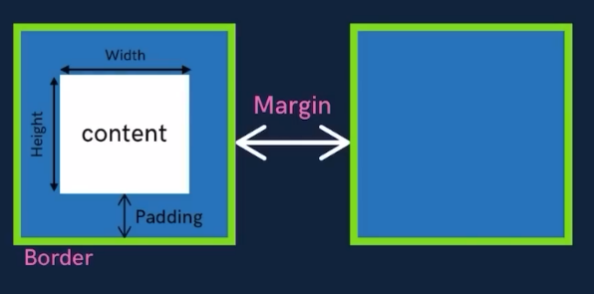
- Box Model
  - Height
  - Width
  - Padding
  - Marging
  - Shorthand
  - Border (2px solid/dotted/dashed black)
  - Border radius
- Practice set nav bar
- Display Property
  - Inline //single line multiple item
  - Block //single line only one item
  - Inline-block //apply margin padding
  - Display: none; //space not reserve
  - Visibility: hidden; //reserved space
- Practice set…4…. Level 3…………………….
- Units in CSS
  - Relative (%, em, rem)
- Position
  - Static/relative/absolute/fixed/sticky
  - Z-index
- background-image: url(“cat.jpg”);
  - background-size: cover/contain/auto
  - background-repeat: no-repeat
- Practice set 5……Level 4……….
- Flexbox (display:flex)
  - Flex-direction: row/row-reverse/column/column-reverse
- Flex Properties
  - Justify-content: center/space-evenly/space-between/flex-start
  - Flex-wrap: nowrap/wrap/wrap-reverse
  - Align-items: center/…..
  - Align-content: center/space-be tween/….
  - Align-self, flex-grow, flex-shrink
- Practice
- Media Queries
  - @media (width/min-width/max-width:600px){div{color:red;}}
- Practice ………..Level 5……
- Transitions
  - Pseudoclass (hover/active)
  - Transition-property:all;
  - Transition-duration:2s/4ms;
  - Transition-timing-function: ease-in/ease-out/linear/steps;
  - Transition-delay:2s/4ms;
  - Shorthand:- transition: all 2s ease-in 1s;
- Transform (2D & 3D)
  - Transform: rotate(45deg);
  - rotate/rotateX/rotateY/rotateZ
- Scale
  - Transform:scale(2 / 0.5 / 1, 2);
  - Transform: scaleX/scaleY(0.5);
- Translate
  - Transform:translate(20px/20px,50px);
  - Transform:translateX/translateY(20px);
- Skew
  - Transform:skew(30deg);
- Animation
  - Animation-name
  - Animation-duration
  - Animation-timing-function
  - Animation-delay
  - Animation-iteration-count:infinite/1.5/2/0/inherit/initial/revert
  - Animation-direction : normal/reverse/alternate/alternate-rev
  - Shorthand:- animation: myName 2s linear 3s infinite normal;
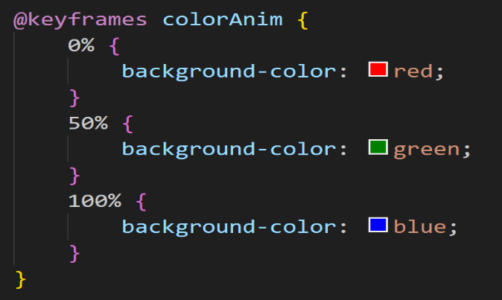
  - % in Animation @keyframne myName
- Practice set
- Project

